Blind Spot

Blind Spot

Activity Overview
Students investigate how AI systems can leave out certain people or groups because of biased or incomplete training data using a hands-on sorting activity with training and test photos.
Learning Objective  Students analyze how the data used to train AI systems affects who AI recognizes or leaves out. | Standards & Competencies  - 1b (Understand Mechanics)  - 2a (Identify and address biases)  - CCSS.ELA.SL.4.1: Engage effectively in collaborative discussions
Materials  - Training Photos  - Test Photos  - Class poster with Fair AI Guidelines | Preparation  - Print and cut a set of Training and Test photos for each group.  - Display Fair AI Guidelines poster.

Launch (2-3 minutes)
Slide | Exploration Guide
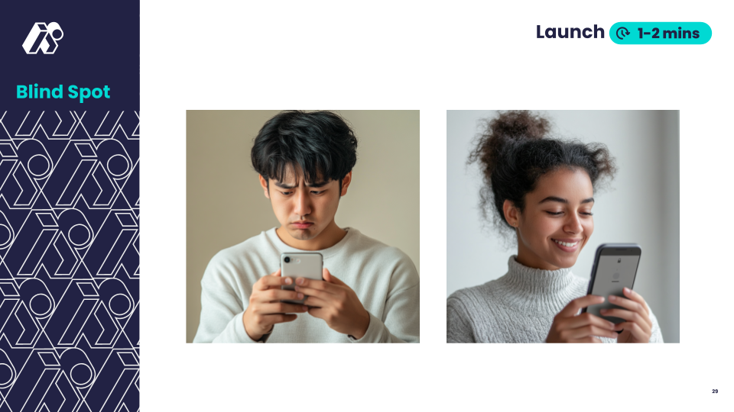 | Say: “Many people can now unlock their phones with their face. Do you think AI can recognize all faces equally? What do you think AI looks for when recognizing a face?"  Students share initial theories about why some faces are recognized. Students predict what might be causing the differences.  Look For:  - "AI looks for eyes, nose, and mouth."  - "Maybe AI works better on some faces than others."  - "It depends on how AI was trained."  Common Misconceptions:  - "AI can figure out any face, even if it hasn’t seen it before."  - Response: "AI only knows what it has been trained on. If it hasn’t seen enough different types of faces, it might make mistakes!"
💡Teaching Tip: Use a think-pair-share to give students processing time to think about the question before sharing aloud. Provide sentence starters for predictions:
- “AI might have trouble recognizing ____ because ____.”
- “Maybe AI works better on ____ faces because ____.”

Play (8-12 minutes)
Slide | Exploration Guide
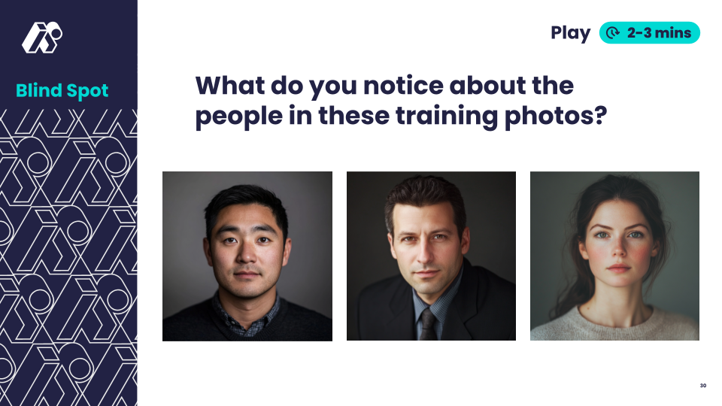 | Say: "Imagine you’re teaching an AI tool to recognize people’s faces. You show it all these photos—this is what it learns from. “  Ask: "What do you notice about the people in these photos? What might happen if AI only learns from these photos?"  Look For:  - "They’re all adults."  - "They all have lighter skin."  - "No one is very old or very young."  - "They're all facing straight ahead"  Common Student Misconceptions:  - "AI can figure out variations it hasn't seen"  - Response: "AI learns from examples - if it doesn't see variety, it doesn't learn variety"
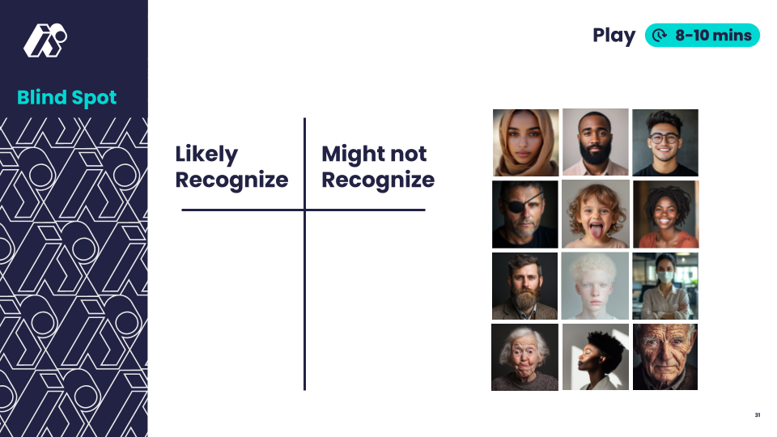 | Say: "Now, let’s predict: If an AI only learned from these training photos, which types of faces might it recognize, and which would it have trouble recognizing?"  Distribute test photos. In pairs or small groups, students categorize into “Might Recognize” and “Might Not Recognize” categories and explain their thinking.  Ask:  - "Why do you think AI might not recognize some of these faces?"  - "What do these faces have that the training photos didn’t?"  Look For:  - "AI struggles with glasses, masks, head coverings."  - "It might miss older people, darker skin tones, or different expressions."
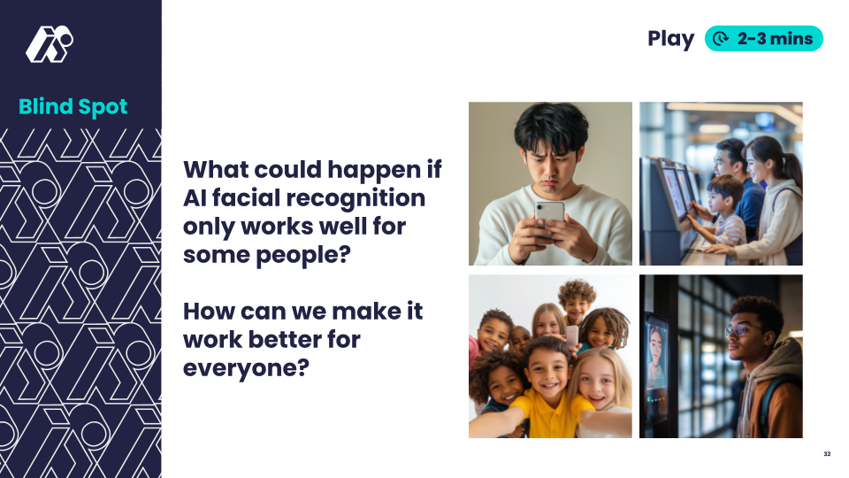 | Say: "Facial recognition is used in real life all around us—on phones, in schools, airports, and even on social media. What could happen if AI only works well for some people in those places?.”  Look For:  - Problems: People won’t be able to unlock their phones, might get stuck at the airport  - Fixes: Train AI on more diverse images, have humans check AI decisions
💡Teaching Tip: Use a graphic organizer to categorize photos (e.g., age, skin tone, accessories). Emphasize that AI isn’t bad—it just depends on what it has been trained on! Offer sentence frames for observations:
- ”AI might struggle with ____ because it only saw ____.”
- “AI learned from ____, so it might not recognize ____.”

Land (5 minutes)
Slide | Exploration Guide
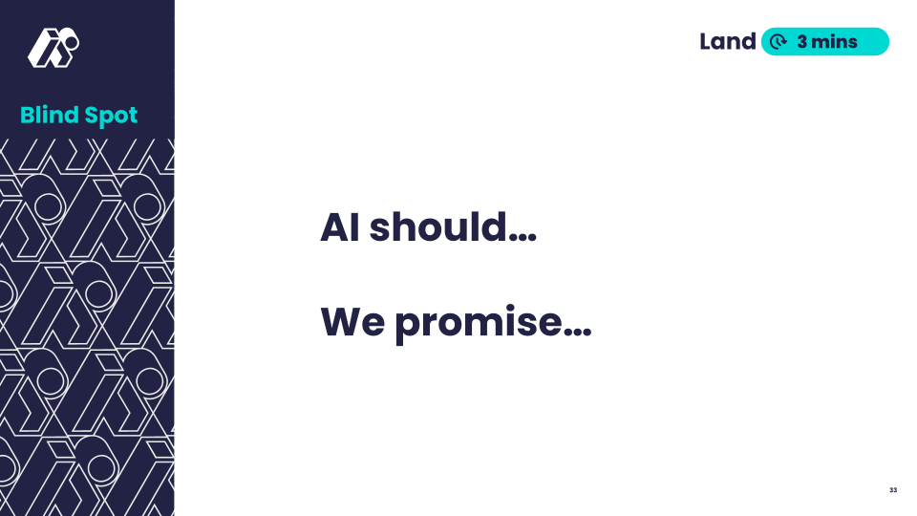 | Say: "Based on our exploration today, how should AI be designed to be fair and responsible in all areas? What can we do to make sure AI is more fair?”  Students propose wording for Fair AI guideline statement. Record statements with students OR show the next slide.  Look For:  - "AI should work for everyone no matter how they look."  - "We should promise to speak up when we notice AI working unfairly."
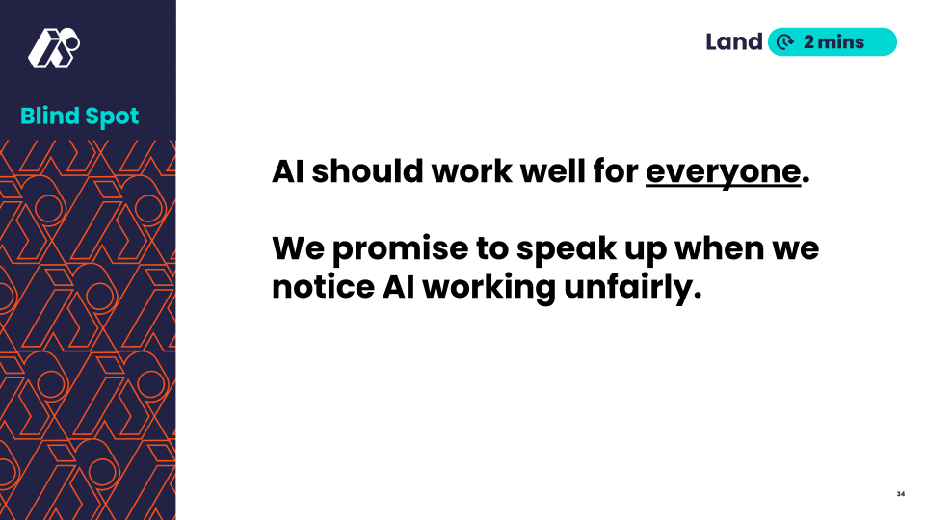 | Share this slide or the written version of the statements agreed upon by the class.  Say: "Here's one way we could phrase our learning. Does this capture our ideas, or do you prefer your wording?
💡Teaching Tip: Encourage students to use their own words - there is no single "right" answer. Post terms like “diverse,” “fairness,” and “recognition” with images to support student-generated guideline statements.

